**4. PROPOSED SYSTEM**

Due to the limitations in transformation, wavelets are introduced in image fusion. Wavelets focus on depth of optical lens relevant to object. To obtain relevant information from the source image, it is essential to focus on all the possible views for human visual perception. The field of signal processing is the base for wavelet transformation but these are applicable for images. Wavelets provide to find out good localization properties in the image. Wavelets are represented with 1-D and 2-D form. To find out 2-D decomposition levels of image, wavelets are useful. Generally wavelets generate frequency components LL, LH, HL, and HH which have been depicted in figure (4.1).

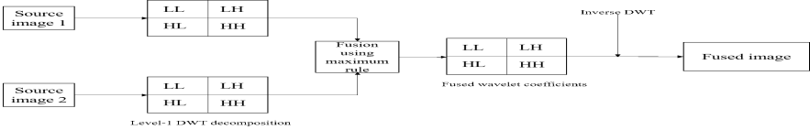

**Figure 4.1.** Wavelet fusion method

Further each frequency component is again divided into the above-said frequency levels. There exist simple average, minimum, and maximum rules to find out decomposition levels of image with respect to wavelets. In maximum rule, it focuses on highest intensity pixels region which results in highly focused image output. If in a particular region each image pixel is compared with another, further, only highest pixel value is assigned to corresponding lowest pixel value. The wavelet transform is applied on single image. It can correspond to by the subsequent Eq. (4.1). Wavelet coefficients are fused by means of the fusion maximum rule Eq. (4.2).

Inverse Modified Discrete Wavelet Transform Maximum Rule (IMDWTMR) is functional on the fused wavelet coefficients to achieve the fused image IF (M1, N2) specified by the subsequent Eq. (4.3).

|  |  |
| --- | --- |
| I(M1,N2)=W(I1(M1,N2)) | (**4.1**) |
| a3(x, y)=max(a1(x, y)) b3(x, y)=max(b1(x, y))  c3(x, y)=max(c1(x, y)) d3(x, y)=max(d1(x ,y)) | (**4.2**) |
| $$IF\left(M_{1},N_{2}\right)=W^{-1}\left(φ\left(W\left(I_{1}\left(M_{1},N_{2}\right)\right)\right)\right)$$ | (**4.3**) |

A schematic illustration of the wavelet fusion method of one input source image I1 (M1, N2) is shown in figure (4.2).

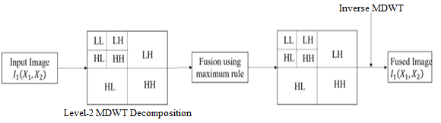

**Figure. 4.2.** Modified Wavelet Fusion Method**.**

The proposed work combined with DCT-FP, DCT-LP, and DCT-MR along with MDWT to get the better fusion for source images. The below figure (4.3), (4.4), (4.5) depict a flow graph of proposed method.

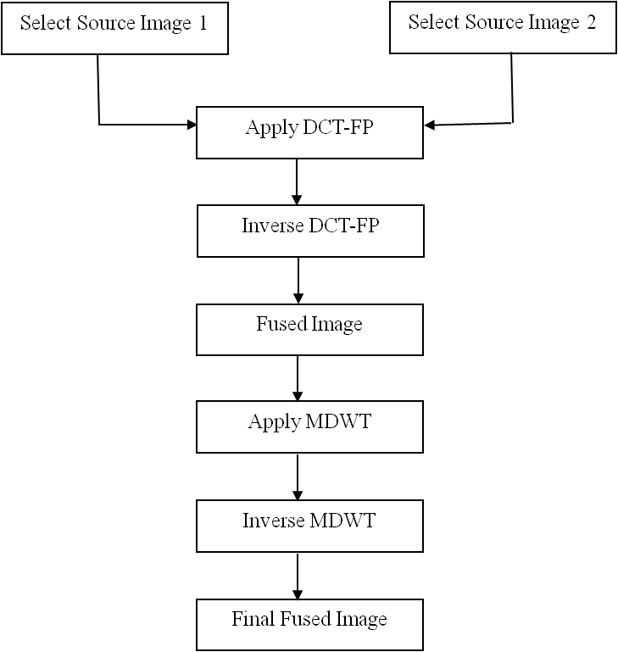

**Figure 4.3**. Flow graph of DCT-FP with MDWT

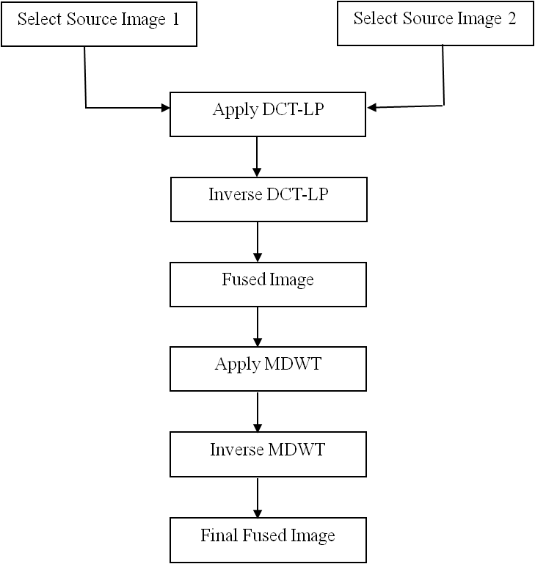

**Figure** **4.4**. Flow graph of DCT-LP with MDWT

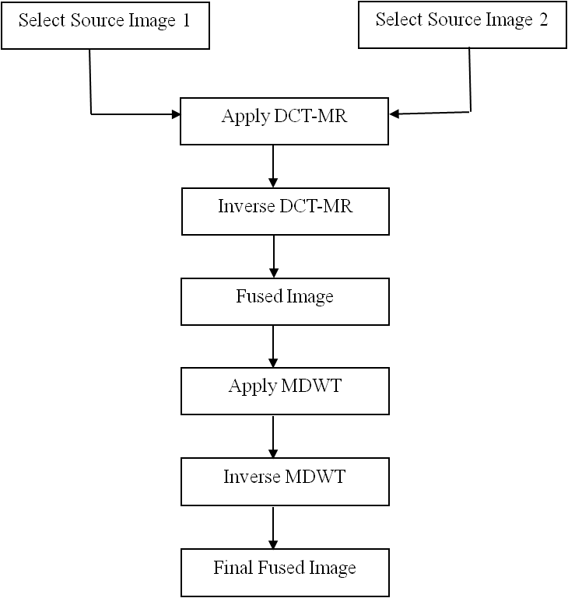

**Figure 4.5**. Flow graph of DCT-MR with MDWT

4.1 ALGORITHMS

1. Algorithm: DCT-FP with MDWT

**Input**: Source Images

**Output**: Fused Image

**Steps**:

1. Select input images

2. Apply DCT- Frequency Partition on input images

3. Find out inverse DCT-FP to obtain the fused image

4. The result of DCT-FP is applied MDWT with maximum rule

5. Find out inverse MDWT

6. Required fused image generated as output.

1. Algorithm: DCT-LP with MDWT

**Input**: Source Images

**Output**: Fused Image

**Steps**:

1. Select input images

2. Apply DCT- Laplacian Pyramid on input images

3. Find out inverse DCT-LP to obtain the fused image

4. The result of DCT-LP is applied MDWT with maximum rule

5. Find out inverse MDWT

6. Required fused image generated as output.

1. Algorithm: DCT-MR with MDWT

**Input**: Source Images

**Output**: Fused Image

**Steps**:

1. Select input images

2. Apply DCT- Multi-resolution on input images

3. Find out inverse DCT-MR to obtain the fused image

4. The result of DCT-MR is applied MDWT with maximum rule

5. Find out inverse MDWT

6. Required fused image generated as output.

4.1.1 Performance Evaluation

Fusion quality can be appraised optically. Human discernment determines fusion quality. Human object evaluators provide grade for the corresponding image (fused) and average the grade. This sort of appraisal has some disadvantages such as the grade is not accurate and the degree of accuracy can be decided by the human observer’s ability. To eliminate the demerits, quantitative measures should be used for accuracy and empirical evaluation of the fused objects.

4.2 WITH ALLUSION IMAGE

If the reference of image is available, the performance of image synthesis algorithms can be assessed by using the below proportions.

**4.2.1 Root Mean Square Error** **(RMSE)**

Computed as the root mean square error of the resultant pixels in the allusion image and synthesized image. A lesser RMSE value means better image synthesis quality. It is computed as:

|  |  |
| --- | --- |
| RMSE = sqrt (sum ((Ir (i, j)-If (i, j)). ^2)/ (M*N)) | (**4**) |

Where

M the number of rows

N the number of columns

(i, j) pixel index

Ir  reference image

If synthesized image

I (i, j) gray value at pixel (i, j)

* + 1. **Peak Signal to Noise Ratio (PSNR)**

Its value will be far above the ground when the synthesized and allusion images are related. A higher PSNR value means better image synthesis quality. It is computed as:

|  |  |
| --- | --- |
| PSNR = 10*log10 (L^2/RMSE) | (**5**) |

Where L is the number of gray levels in the image

* + 1. **Mean Absolute Error** **(MAE)**

Computed as the mean absolute error of the resultant pixels in allusion and synthesized images. A lower MAE value means better image synthesis quality. It is computed as:

|  |  |
| --- | --- |
| MAE = sum (sqrt ((Ir (i, j)-If (i, j)). ^2))/ (M*N) | (**6**) |

* + 1. **Percentage Fit Error (PFE)**

Percentage Fit Error is calculating the norm of the difference between the corresponding pixels of the allusion and synthesized image to norm of the allusion image. If the calculate value is zero, then both the allusion and the synthesized images are same and numbers will be increased when the combined image is not same to the allusion image. A lower PFE value means better image synthesis quality. It is computed as:

|  |  |
| --- | --- |
| PFE = 100*norm (Ir (i, j)-If (i, j))/norm (Ir (i, j)) | (**7**) |

Where norm: is the operator to calculate the biggest singular value

* + 1. **Signal to Noise Ratio (SNR)**

A superior SNR value means enhanced image synthesis quality. It is computed as:

|  |  |
| --- | --- |
| SNR = 10*log10 (ST/NTF) | (**8**) |

Where

ST mean (mean ((double (Ir)). ^2))

NTF mean (mean ((double (Ir-If)). ^2))

* + 1. **Correlation (CORR)**

This depicts the correlation between the allusion and synthesized image. The ideal value is one when the allusion and synthesized are exactly alike and it will be less than one when the dissimilarity increases. A higher CORR value means better image synthesis quality. It is computed as:

|  |  |
| --- | --- |
| CORR = 2*RTF/(RT+RF) | (**9**) |

Where

RTF sum (sum (Ir.*If))

RT sum (sum (Ir.*Ir))

RF sum (sum (If.*If))

4.3 WITHOUT ALLUSION IMAGE

If allusion image is not available, then recital of image synthesis methods can be evaluated by means of below measurements:

**4.3.1 Entropy (EN)**

It is useful to measure the information content of a synthesized image. The large entropy value indicated by synthesized image has high information contents. It is computed as:

|  |  |
| --- | --- |
| Entropy (If) | (**10**) |